Balkan Olympiad in Informatics 2007  Chisinau, Moldova |  | Country
Task: Mokia |  | Day 2

Mokia

The Moldovan Mobile Phone Company Mokia has designed a new customer location system. Like any location system, it can answer easily, with millimeter precision, any query of the type “What is the position of the customer C?”, but the real advance in technology is the ability to answer to queries of the type “How many customers are there in a given rectangular area?”.
In the location system the world is viewed as a square area with a certain size, composed of elementary squares of size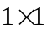. An elementary square is defined by its (x, y) indices, 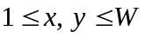. The indexing starts at 1, e.g. for a table of size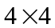, we have 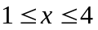 and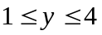 (see the picture).
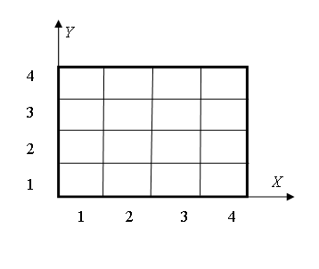
Please help Mokia and write a program that computes how many customers are there in a given rectangular area.

Input and Output. The input is read from the text file mokia.in as integers and the answers to the queries are written to mokia.out as integers.
The input is encoded as follows. Each input comes on a separate line, and consists of one instruction integer and a number of parameter integers according to the following table.

Instruction | Parameters | Meaning
0 | W | Initialize the matrix size to containing all zeros. This instruction is given only once and it will be the first instruction.
1 | x y A | Add A to the number of customers in table square (x, y). A will be a positive integer.
2 | X₁ Y₁ X₂ Y₂ | Query the current number of customers in squares (x, y), where 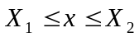 and 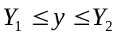.
3 | No parameters | Terminate program. This instruction is given only once and it will be the last instruction

Your program must not answer anything to input lines with an instruction other than 2. If the instruction is 2, then your program is expected to answer the query by writing the answer as a single line containing a single integer to the output file.

Example.

mokia.in |  | mokia.out
0 4  1 2 3 3  2 1 1 3 3  1 2 2 2  2 2 2 3 4  3 |  | 3  5

Explanation:

Input file | Output file | Meaning
0 4 |  | Table size is , filled with zeroes.
1 2 3 3 |  | Add 3 customers at (2, 3).
2 1 1 3 3 |  | Query sum of rectangle 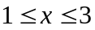, 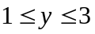.
 | 3 | Answer.
1 2 2 2 |  | Add 2 customers at (2, 2).
2 2 2 3 4 |  | Query sum of rectangle 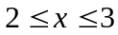, 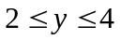.
 | 5 | Answer
3 |  | Exit your program.

Restrictions. 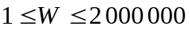, 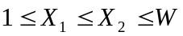, 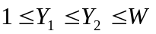, 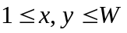; 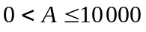. The number of “1” (Add) instructions will not exceed 160000. The number of “2” (Query) instructions will not exceed 10000. CPU time must not exceed 5.0 seconds. Memory consumption must be not greater than 128 MB. Your source code must be named mokia.pas, mokia.c or mokia.cpp.

